Settlement Agent eSign Instructions

If all parties and documents are not signed correctly on the day of closing, the loan must re-close. This may impact the lender lock expiration, borrower right to cancel dates and delay PRMI in being able to sell loans to aggregators. PRMI may seek the cost for any losses due to signing errors if these instructions and the instructions in the Invitation Confirmation emailed to you by Doc Magic.
All loans will include an eNote. You can identify an eNote in the Document Name column. The name of the Note will include Electronic Note. If you do not see this document, you must contact the PRMI loan closer. Under no circumstances can an eNote be ink signed.
Doc Magic customer support: 800-649-1362.

Follow these steps to proceed:
- Enter Viewing Code to access the loan documents in DocMagic.
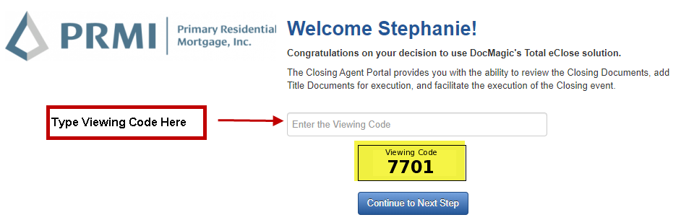
- Navigate to the Documents Tab and print any “Ink” sign documents that the borrower(s) and notary must sign. The “Ink” sign documents will include a Cover Sheet that must be page one of any document set you re-upload. Doc Magic will only recognize signed documents uploaded with the Cover Sheet as page one.
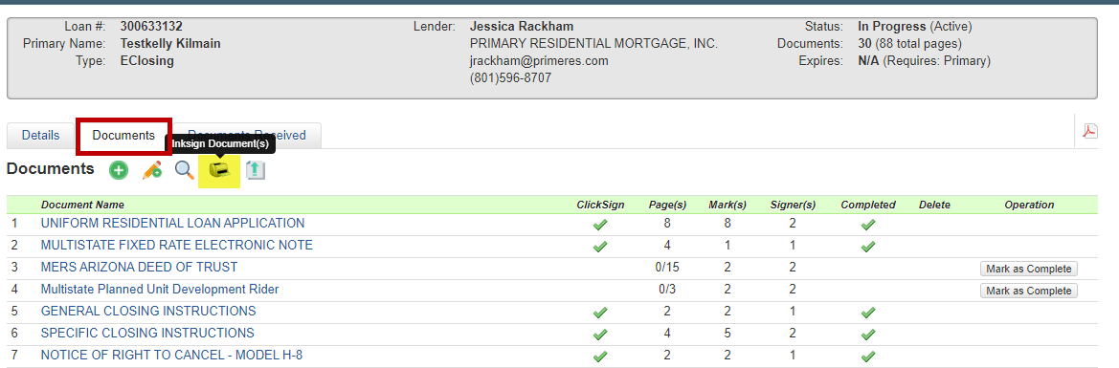
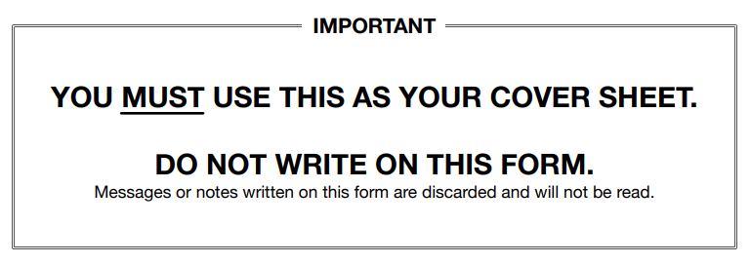
- Navigate to the Details Tab to confirm the Preview Mode is turned off on the day of closing. If it is not Off, click Preview Mode to turn off. eSigning is disabled for any party when Preview Mode is On.
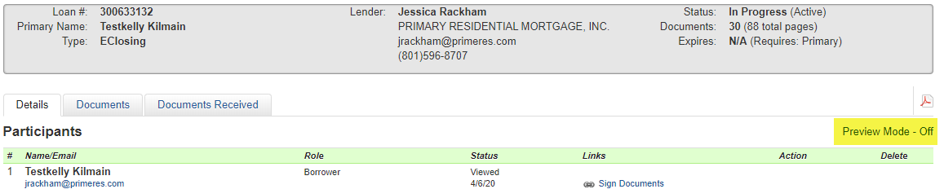
- On the day of closing you are responsible to make sure the borrower(s) have eSigned all their required documents. You can confirm they were eSigned by reviewing the Completed column in the Documents tab. Once all parties have eSigned a green checkmark will be visible.
NOTE: all documents; ink signed and eSigned must be complete on the same day.
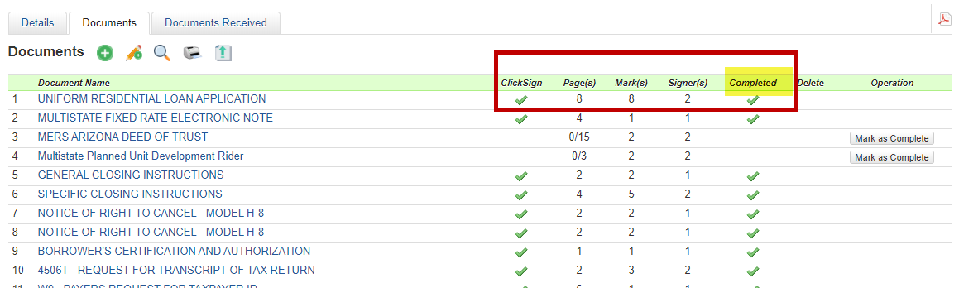
- Click Sign checkmark indicates the document listed to the left is to be eSigned.
- Page(s) represent the number of pages for the document.
- Mark(s) represent how many eSignatures are required on the document.
- Signer(s) represent how many people are required to sign the document.
- Completed checkmark indicates all signers have completed eSigning the document.

- Settlement Agent must complete their eSigning process by navigating to the Details tab and clicking on the Sign Documents link. Some of the documents the settlement agent will sign include the Closing Instructions and USA Patriot Act Customer Identification Verification form. You will be able to type in the customer identification information on the form.
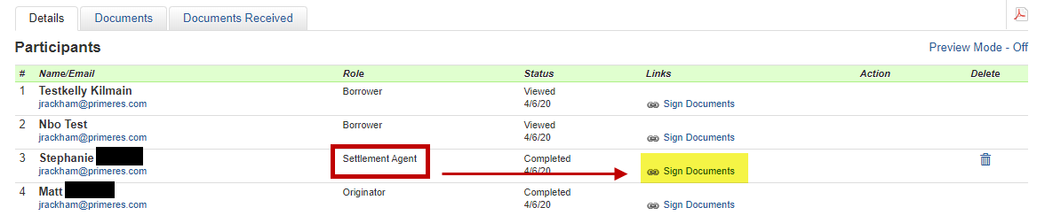

- Upload all executed “Ink” signed documents using the Cover Sheet as page one.
